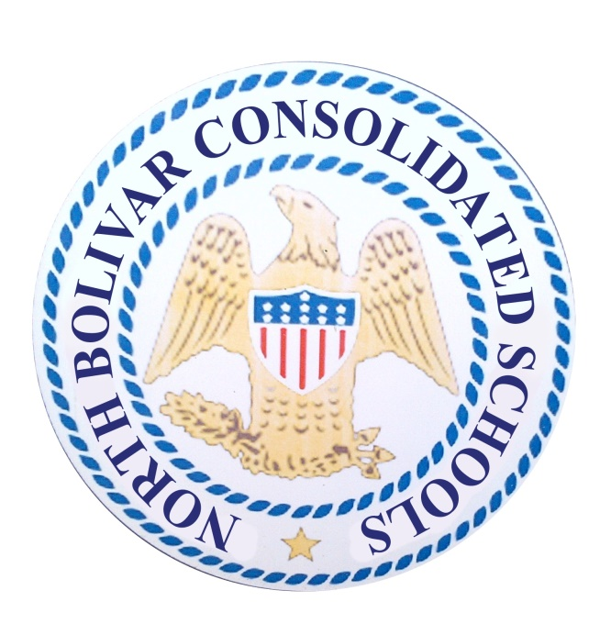

OFFICE OF FEDERAL PROGRAMS
DISTR ICT PARENTAL ENGAGEMENT PLAN
2019-2020

North Bolivar Consolidated School District
Parental Involvement Plan
2019-2020

North Bolivar Consolidated School District Mission Statement and Core Beliefs

The mission of the North Bolivar Consolidated School District is to work in partnership with the community, parents and students. the North Bolivar Consolidated School District is committed to excellence by challenging our students to achieve their highest potential and preparing our students to compete in and ever-changing global society by developing 21st Century learning and thinking skills through a rigorous, relevant, and comprehensive curriculum while preparing students to be innovative and productive citizens in an interconnected world.

We believe that:
- education is a partnership between students, teachers, administrators, parents, businesses, and the community.
- a quality education is a life-long process that fosters academic and cultural understanding.
- all students have the capacity to learn and the right to reach their full potential through a progressive education.
- high expectations yield high student achievement.

Part I. GENERAL EXPECTATIONS

The North Bolivar Consolidated School District agrees to implement the following requirements in accordance with section 1116 of Every Student Succeeds Act (ESSA) as listed below. North Bolivar Consolidated School District Schools will distribute this policy to parents of students participating in the Title I program.

The school district will put into operation programs, activities and procedures for the engagement of parents in all of its schools with Title I, Part A programs, consistent with section 1118 of the Elementary and Secondary Education Act (ESEA). Those programs, activities and procedures, including the process of school review and improvement under section 1116, will be planned and operated with meaningful consultation with parents of participating children.

Consistent with section 1116, the school district will work with its schools to ensure that the required school-level parental involvement policies meet the requirements of section 1116(b) of the ESSA, and each include, as a component, a school-parent compact consistent with section 1116(d) of the ESEA.

The school district will incorporate this district wide parental engagement policy into its LEA plan developed under section 1112 of the ESEA.

In carrying out the Title I, Part A parental involvement requirements, to the extent practicable, the school district and its schools will provide full opportunities for the participation of parents with limited English proficiency, parents with disabilities, and parents of migratory children, including providing information and school reports required under section 1111 of the ESSA in an understandable and uniform format and including alternative formats upon request and, to the extent practicable, in a language parents understand .

If the LEA plan for Title I, Part A, developed under section 1112 of the ESEA, is not satisfactory to the parents of participating children, the school district will submit any parent comments with the plan when the school district submits the plan to the Mississippi Department of Education.

The school district will engage parents of children served in Title I, Part A schools in decisions about how the one (1) percent of Title I, Part A funds reserved for parental involvement is spent, and will ensure that not less than ninety-five (95) percent of the one (1) percent reserved goes directly to the schools.

The school district will provide such other reasonable support for parental engagement activities under section 1118 of the ESEA as the parents may request.

The school district will be governed by the following statutory definition of parental involvement, and expects that its Title I schools will carry out programs, activities, and procedures in accordance with this definition:

Parental engagement means the participation of parents in regular, two-way, and meaningful communication involving student academic learning and other school activities, including ensuring:

(A) That parents play an integral role in assisting their child's learning;

(B) That parents are encouraged to be actively involved in their child's education at school;
(C) That parents are full partners in their child's education and are included, as appropriate, in decision-making and on advisory committees to assist in the education of their child;
(D) The carrying out of other activities, such as those described in section 1118 of the ESEA.

PART II. HOW DISTRICT WILL IMPLEMENT REQUIRED PARENTAL ENGAGEMENT POLICY COMPONENTS

- The North Bolivar Consolidated School District will take the following actions to engage parents in the joint development of its district wide parental engagement plan and the process of school review and improvement:

- The District shall convene an annual meeting for parents of Title I students, teachers, Title 1 staff, Principals at Title I schools, and program administrators for the purpose of providing direction, support, and education for the general operation of the Title I parent engagement component and for the development of the district Title I Parent Engagement Plan.

- At its annual meeting, parents and others in attendance will review student achievement data as part of its agenda.

- The North Bolivar Consolidated School District will provide the following necessary coordination, technical assistance, and other support to assist Title I, Part A schools in planning and implementing effective parental involvement activities to improve student academic achievement and school performance:

- Approving reasonable and necessary expenses associated with parent engagement activities, including supplies and materials, to enable parents to participate in school related meetings and training sessions.

- Ensuring school-parent compacts are being used to outline responsibilities of the school, staff, parents, and students in striving to raise student achievement and explain how an effective home-school partnership will be developed

- Educating teachers, school personnel, and administrators on how to improve parent involvement and work with parents as equal partners.

- Assisting schools, parents and parental organizations by informing them of the existence of resources and training available within the community through the use of school and district websites, school and teacher newsletters, and PTO organizations.

- Providing full opportunities for the participation of parents who are economically disadvantaged, have limited English proficiency, parents with disabilities, or are parents of migratory children, including providing information and school reports in a language and form parents can understand.

- The North Bolivar Consolidated School District will coordinate and integrate parental engagement strategies in Title I - Part A with parental engagement strategies with Head Start.

- Feeder schools will provide parents with necessary information about how to enroll students in school.

- Parents will be invited and asked to participate in Open-House nights as well as Parent -Teacher Organizational meetings and Parent Engagement Activities at the local school.

- The North Bolivar Consolidated School District will take the following actions to conduct, with the involvement of parents, an annual evaluation of the content and effectiveness of this parental engagement policy in improving the quality of its Title I, part a schools. The evaluation will include identifying barriers to greater participation by parents in parental engagement activities (with particular attention to parents who are economically disadvantaged, are disabled, have limited English proficiency, have limited literacy, or are of any racial or ethnic minority background). The school district will use the findings of the evaluation about its parental engagement policy and activities to design strategies for more effective parental engagement, and to revise, if necessary (and with the involvement of parents), its parental engagement policies.

- A meeting of all stakeholders will be held at the NBCSD administrative office to determine the effectiveness of the District Policy and need for revision. The meeting will be held by the District Parent Engagement Coordinator and the local school Parent Liaisons.

- An evaluation will be completed and submitted to the Federal Programs Director and a copy made available to all other stakeholders.

- The North Bolivar Consolidated School District will build school and parent capacity for strong parental engagement, in order to ensure effective engagement of parents and to support a partnership among the school involved, parents, and the community to improve student academic achievement through the following activities specifically described below:

- The school district will, with the assistance of its Title I – Part A schools, provide assistance to parents of children served by the school district or school, as appropriated, in understanding topics such as the following:

- The State's academic content standards

- The state's student academic achievement standards {MS College and Career Readiness Standards)

- The state and local academic assessments including alternate assessments

- The requirements of Title I - Part A

- Importance of Attendance

- How to monitor their child's progress

- How to work with educators

- Parent workshops will be offered on a variety of topics including literacy and mathematics

- Parents will be informed about conferences, classes, and workshops through the use of the school's parent engagement web site and information sent home by students

- Resource materials and brochures will be offered to parents during school activities, parent meetings, and sent home by students

- The school district will, with the assistance of its schools, provide materials and training to help parents work with their children to improve their children's academic achievement, such as literacy training, using technology, as appropriate, to foster parental involvement by:

- Workshops about educational technology, such as relevant software and websites

- Workshops associated with PTO meetings

- Informational meetings conducted by school counselors, classroom teachers, parent liaisons and/or NBCSD lead teachers and administrators

- The North Bolivar Consolidated School District will, with the assistance of its schools and parents, educate its teachers, pupil services personnel, principals and other staff, in how to reach out to communicate with, and work with parents as equal partners in the value and utility of contributions of parents, and in how to implement and coordinate parent programs and build ties between parents and schools by:

- Professional Development opportunities

- Professional Publications, articles, newsletters

- Resource materials available to schools

- The North Bolivar Consolidated School District will, to the extent feasible and appropriate, coordinate and integrate parental engagement programs and activities with Head Start and other programs. The school will also conduct other activities, such as parent resource centers, that encourage and support parents in more fully participating in the education of their children by:

- School parent resource centers will be open during the school day and at other scheduled times for parents to check out educational materials and parent resources.

- Information about all school activities that is appropriate to other programs will be sent out to the directors of the programs.

- The North Bolivar Consolidated School District will take the following actions to ensure that information related to the school and parent-programs, meetings, and other activities is sent to the parents of participating children in an understandable and uniform format, including alternative formats upon request, and, to the extent practicable, in a language the parents can understand:

- All notices to parents will be translated to the extent feasible so that parents will know when meetings take place

- A translator will be provided if requested for limited English parents

- An interpreter can be provided for the hearing impaired

PART III. DISCRETIONARY SCHOOL PARENT ENGAGEMENT POLICY COMPONENTS

Other activities that the school district, in consultation with its parents, chooses to undertake to build parents' capacity for involvement in the school and school system to support their children's academic achievement, such as the following discretionary activities listed under section 1118(e) of the ESEA:

- In order to maximize parental involvement and participation in their children's education, arranging school meetings at a variety of times (minimum of 2 opportunities per scheduled meeting)

- Establishing a district wide parent advisory council to provide advice on all matters related to parental involvement in Title I - Part A

- Providing other reasonable support for parental engagement activities under section 1118 as parents may request

PART IV. ADOPTION

This Plan was adopted by the North Bolivar Consolidated School District School Board on

_________________________________________

The North Bolivar Consolidated School District will distribute this plan to all parents of participating Title 1 - Part A children each year.

Signatures:

Mr. Maurice Smith, North Bolivar Consolidated School District Superintendent

Mr. Jefferick D. Butler, North Bolivar Consolidated School District Board President

